Article Analysis

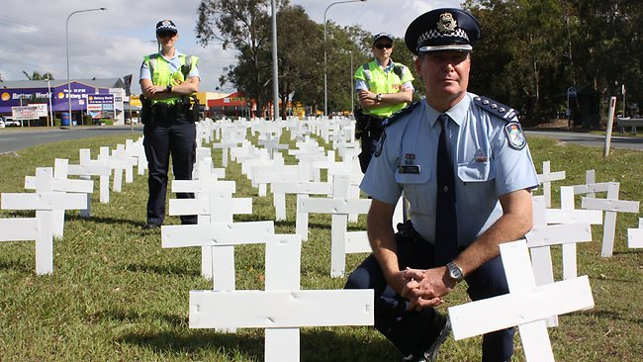

POLICE LAUNCH ROAD BLITZ

For every white wooden cross on the solitary Norfolk Island pine in Ozone Reserve, East Perth, someone has died in on WA roads this year.
The branches are laden. So far, 241 people have died the worst road toll for seven years.
Yesterday, police launched a road safety campaign for the Christmas-New Year period in a bid to stop the killing.
As wells as increased random breath testing and roadside speed traps, 22 new mobile radar units will be used in the campaign.
According to commissioner Bob Falconer, red crosses will be added to the pine if there are more deaths during the campaign. Known as operation safe roads, which began at 12:01am this morning and will end at 11:59pm on January 3.
Mr Falconer said motorcyclists and pedestrians were in part responsible for the year’s high toll - extra 17 motorcyclists and 18 pedestrians have died compared with last year.

- Who do you think is responsible for the high number of deaths on W.A roads? If you think there is more than one person/group list them in order from most responsible to least responsible.

2) What measures do you think should be taken to reduce the road toll?
Try to match up your answer with the people/groups identified above.

3) Are our roads over or under policed? Explain the reasoning behind your answer.

